**ST10486114**  
**Papi Thwala**

**Quiz Master**

A simple and interactive Quiz App built using **Android Studio** and **Kotlin**. This app allows users to test their knowledge by answering questions. It tracks the score, provides immediate feedback, and gives you an option to try again if your score is low.  
It also gives you a chance to review questions.  
You can be able to exit the App.  
  
  
**Features**   
  
• ✅ **Instant Feedback**: Know immediately whether your answer is correct or not.

• 🧮 **Score Calculation**: Your score is calculated in real-time based on your answers.

• 🔁 **Restart Quiz**: Didn't score well? Easily restart the quiz to try again.

• 🔍 **Review Questions**: Review your answers at the end of the quiz to learn and improve.  
• 🚪 **Exit Option**: Exit the app anytime with a simple button click  
  
  
  
**Screenshots**

**Activity Main**  
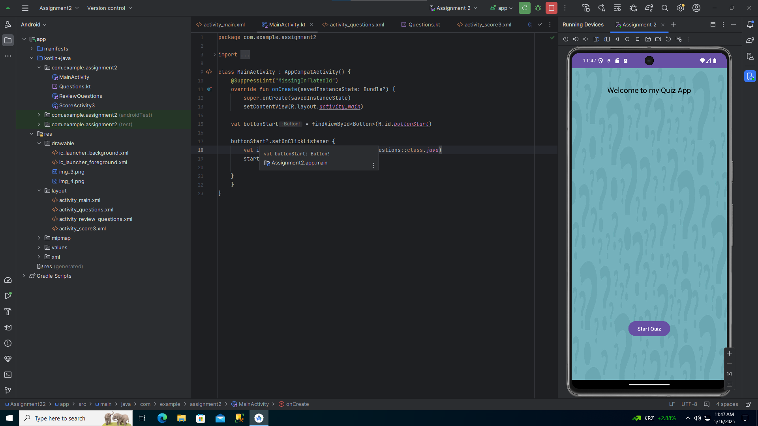

**Questions, Kt**  
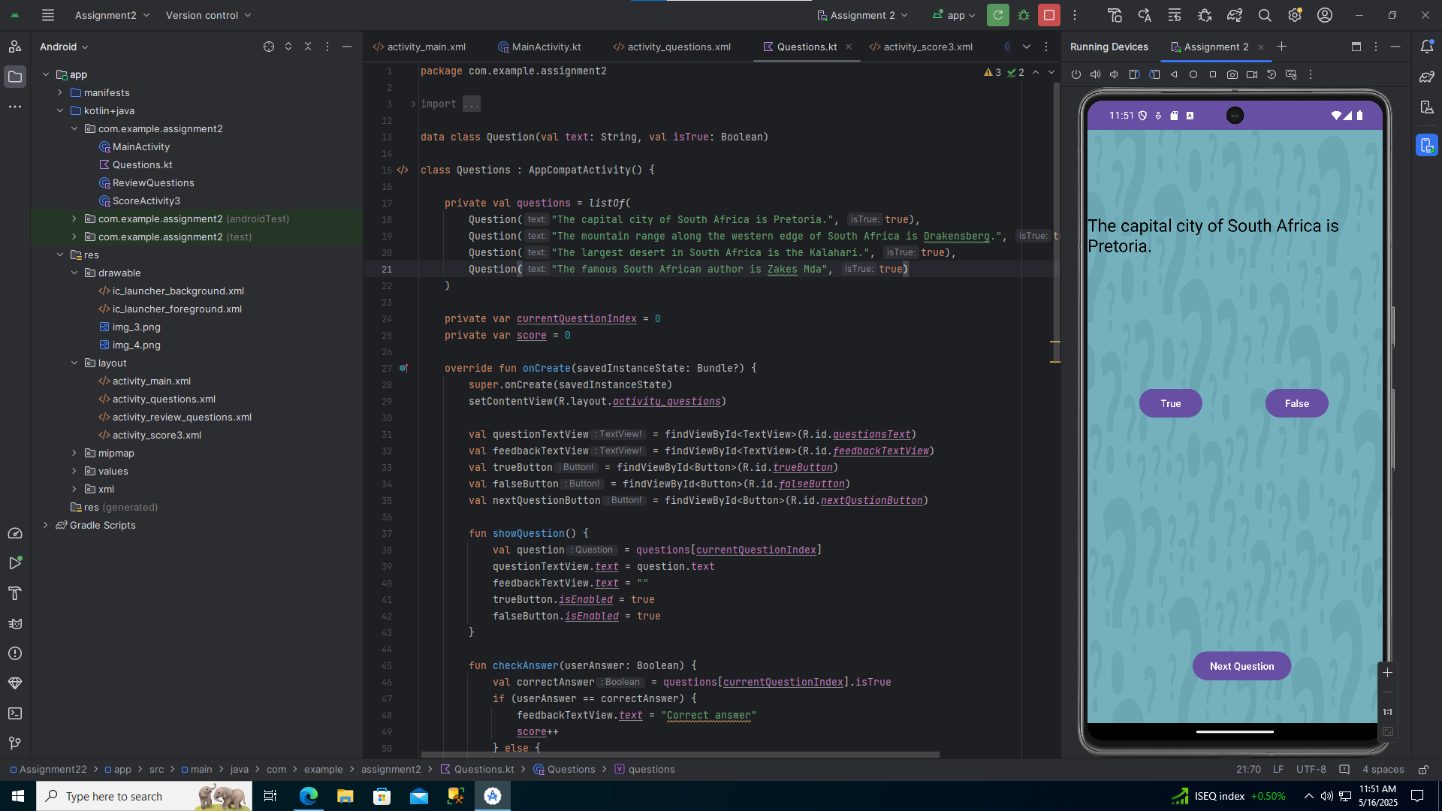

**Score. Kt**  
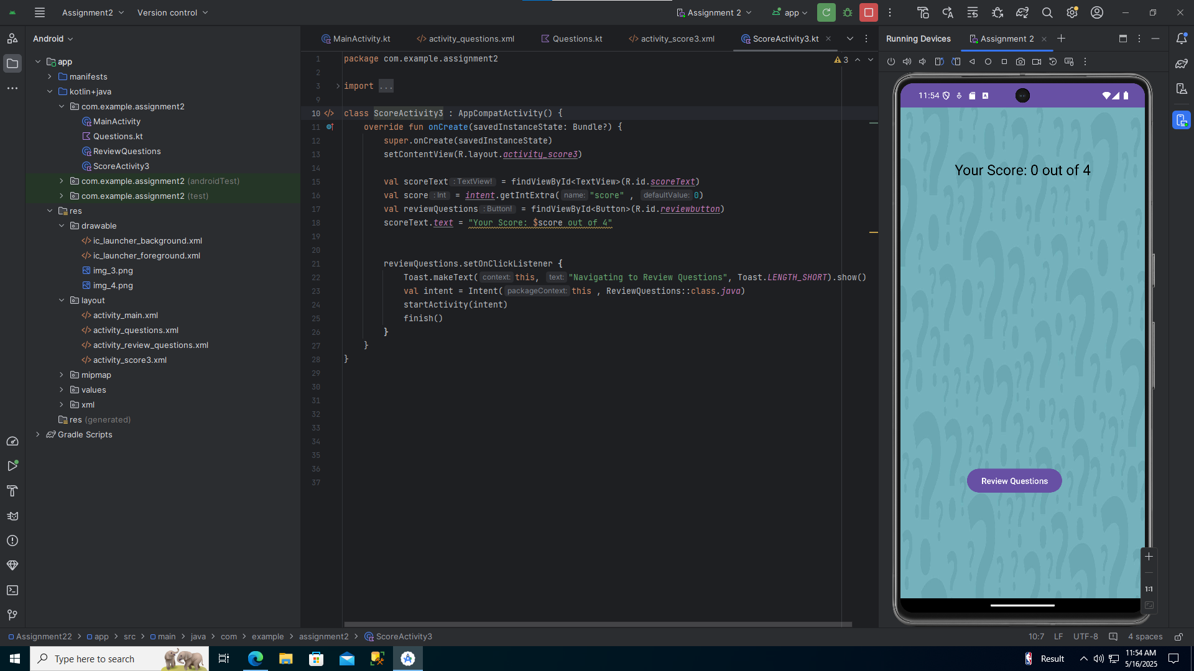

**Review Questions. Kt**  
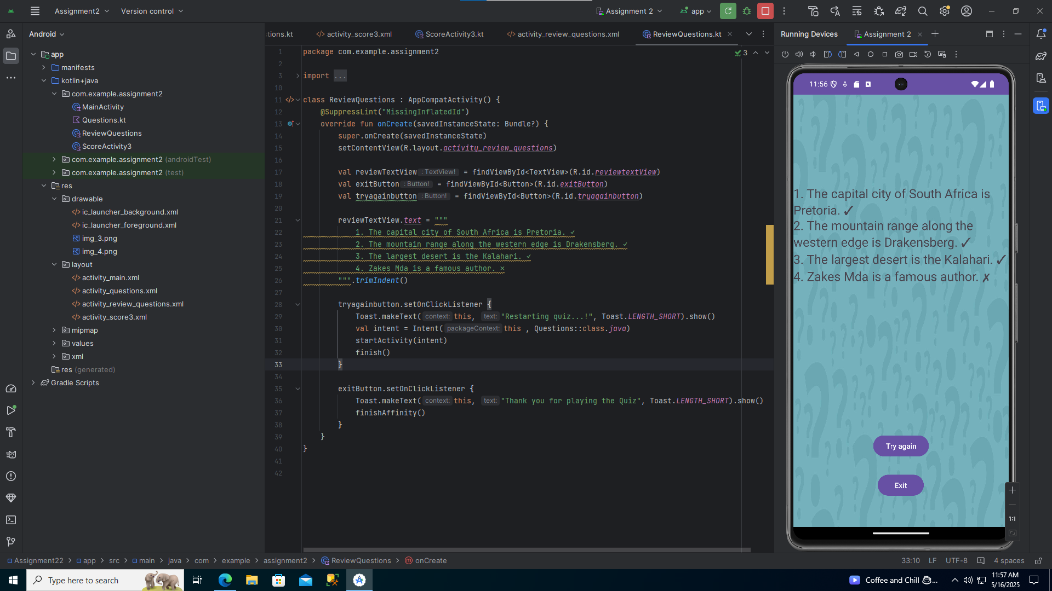

**REFERENCE**   
  
GitHub Docs, 2025. Getting Started with GitHub. [online] Available at: https://docs.github.com/en/get-started [Accessed 29 Apr. 2025].

Mozilla Developer Network (MDN), 2025. Working with Arrays. [online] Available at: https://developer.mozilla.org/en-US/docs/Web/JavaScript/Reference/Global_Objects/Array [Accessed 29 Apr. 2025].

GeeksforGeeks, 2025. Loops in Programming. [online] Available at: https://www.geeksforgeeks.org/loops-in-programming/ [Accessed 29 Apr. 2025].

Guru99, 2025. Software Testing – Manual Testing Basics. [online] Available at: https://www.guru99.com/manual-testing.html [Accessed 29 Apr. 2025].  
  
The Independent Institute of Education (The IIE), 2025. IMAD5112A2 – Flashcard Quiz App Project Guidelines. [online] Available at: https://advtechonline.sharepoint.com [Accessed 29 Apr. 2025].

W3Schools, 2025. JavaScript Arrays. [online] Available at: https://www.w3schools.com/js/js_arrays.asp [Accessed 29 Apr. 2025].